**NodeJs-- What is Nodejs ?**

1.It is javascript runtime build on chrome v8 js engine.

2.nodejs is a open source and cross-platform.

3.client and server side lang.

4.Node runs on a server not in a browser(backend not frontend)

5.The console is the terminal window

Console.log(“hello world”)

6.server.js file

Run cmd- node server

7.console.log(global)- Shows the timing

**What Can Node.js Do?**

* Node.js can generate dynamic page content
* Node.js can create, open, read, write, delete, and close files on the server
* Node.js can collect form data
* Node.js can add, delete, modify data in your database

# Node.js Get Started-

## Download Node.js

The official Node.js website has installation instructions for Node.js: [https://nodejs.org](https://nodejs.org/)

# Node.js Modules-

## What is a Module in Node.js?

Consider modules to be the same as JavaScript libraries.

## 1.Include Modules-

To include a module, use the require() function with the name of the module:

var http = require('http');

# 2.Built-in Modules-

# [assert](https://www.w3schools.com/nodejs/ref_assert.asp), [events](https://www.w3schools.com/nodejs/ref_events.asp)

## Node.js as a Web Server-

var http = require('http');  
  
//create a server object:  
http.createServer(function (req, res) {  
  res.write('Hello World!'); //write a response to the client  
  res.end(); //end the response  
}).listen(8080); //the server object listens on port 8080

Ex-For checking path and directory:

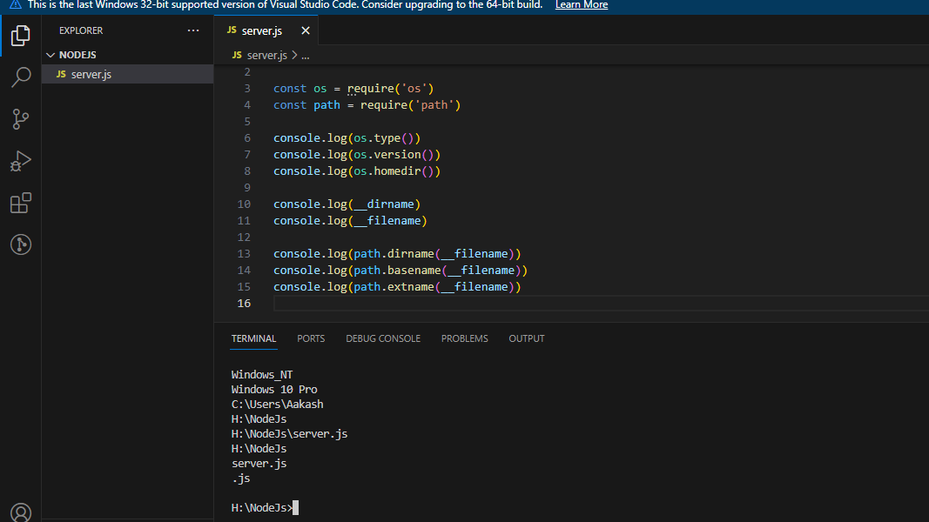

Ex-

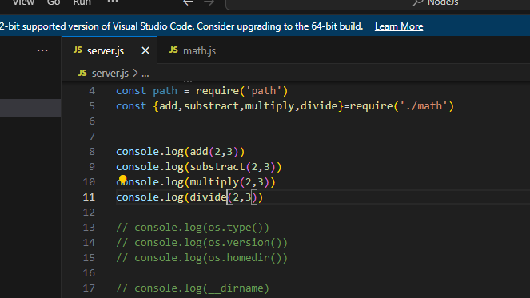

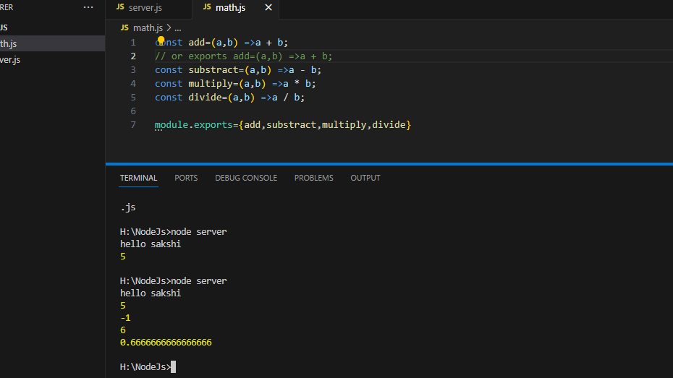

Chapter 2-Creating a new file-Read and write file

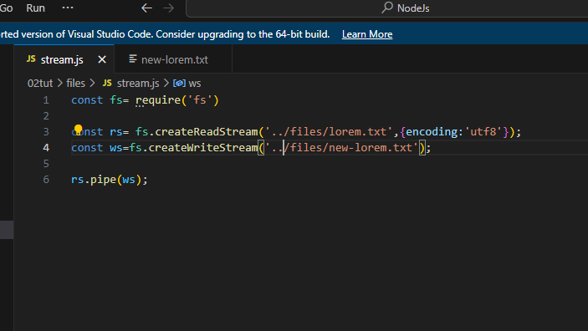

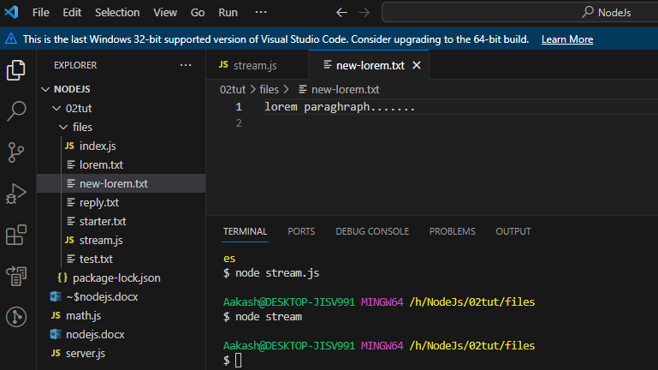

Chapter 3-NPM module

1.install nodemon🡪npm install –g nodemon

2.nodemon install then

3.npm init

4. npm i date -fns🡪Install this pckg as a dependency

5.add this dependency🡪npm i uuid

6.npm rm nodemon –D 🡪 use for uninstall dependency

**When to use NodeJS**

**- I/O Bound**

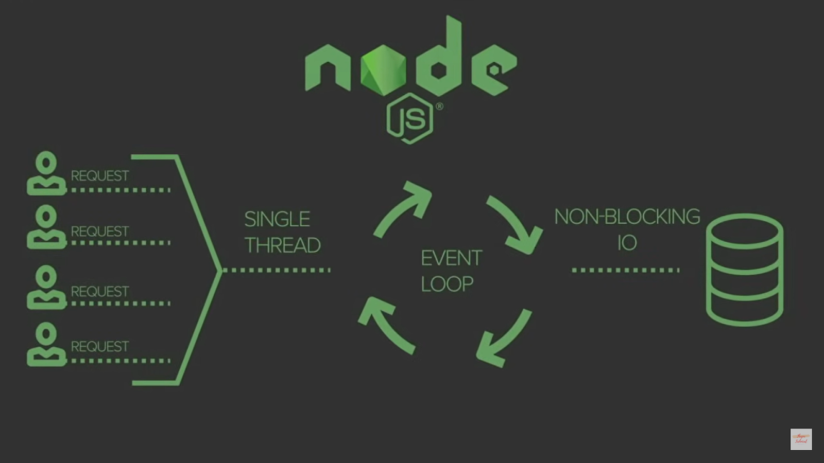

## The EventEmitter Object

You can assign event handlers to your own events with the EventEmitter object.

In the example below we have created a function that will be executed when a "scream" event is fired.

To fire an event, use the emit() method.

var events = require('events');  
var eventEmitter = new events.EventEmitter();  
  
//Create an event handler:  
var myEventHandler = function () {  
  console.log('I hear a scream!');  
}  
  
//Assign the event handler to an event:  
eventEmitter.on('scream', myEventHandler);  
  
//Fire the 'scream' event:  
eventEmitter.emit('scream');

**Intro to ExpressJs framework-**

npm i express



Routing-

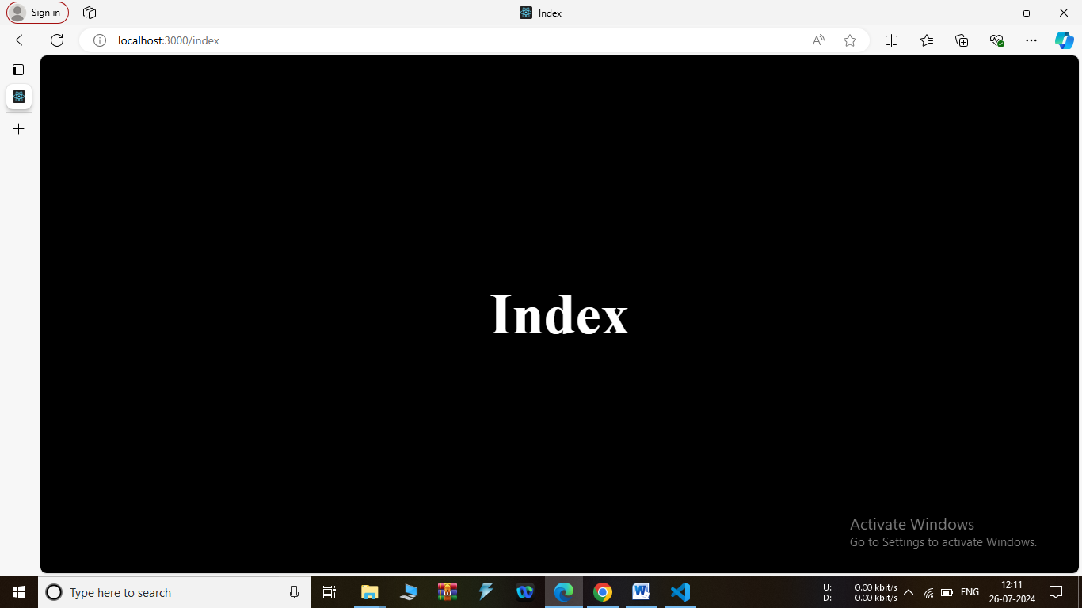

use thunder client –for send request-

1.first install thunder client in :-

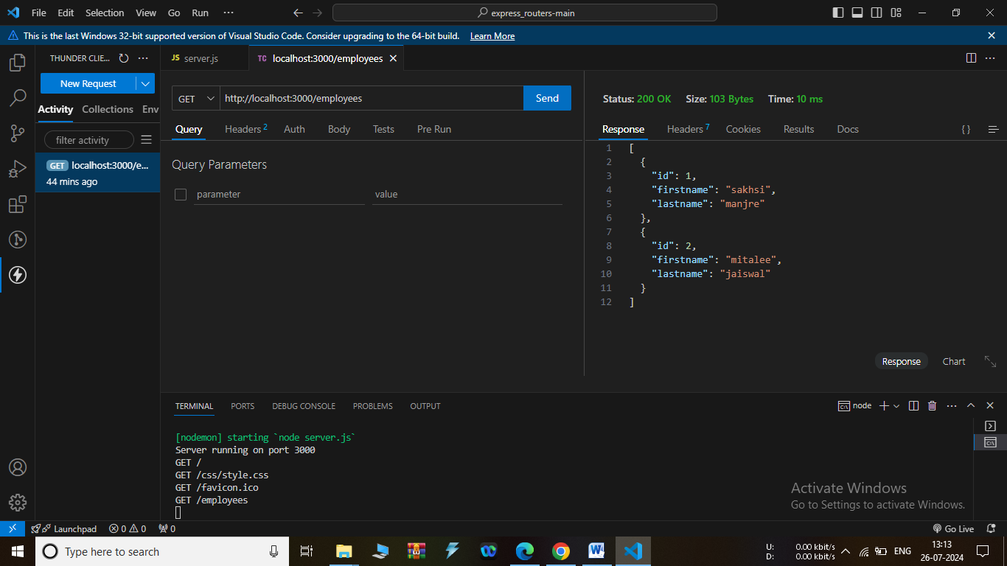

**09MVCRestApi-**

Crud-

Get api-

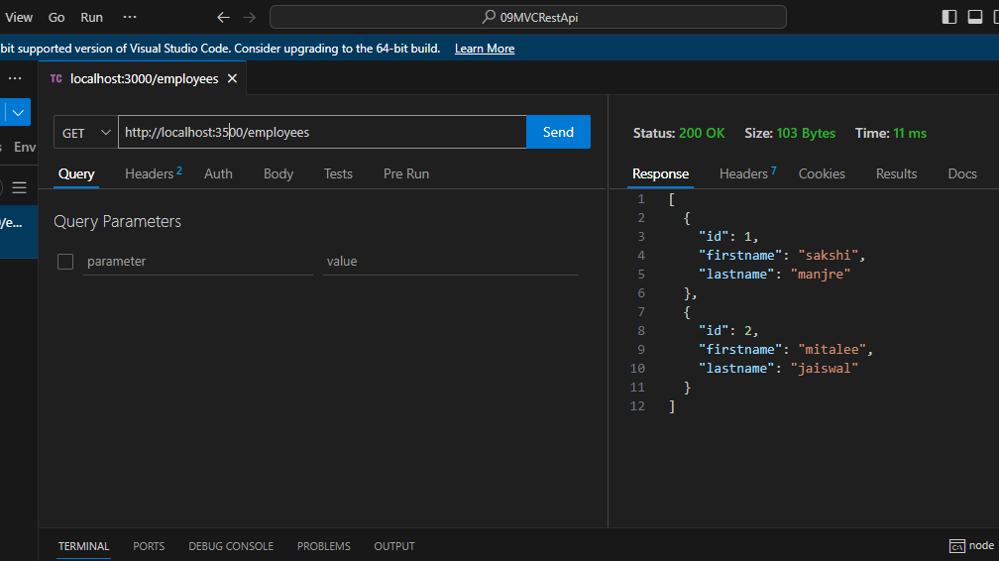

Post-

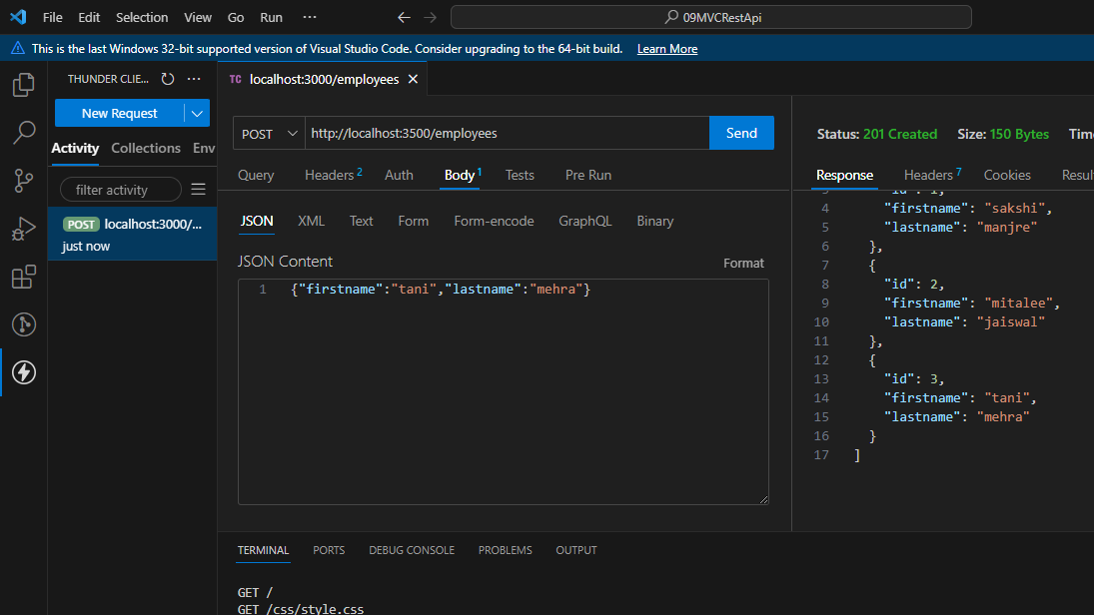

Put-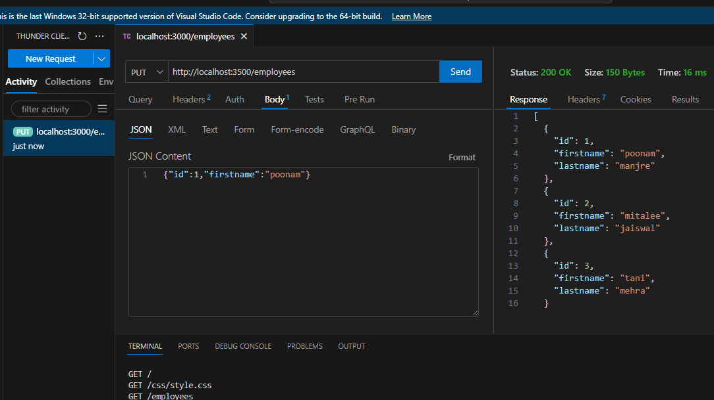

Delete-

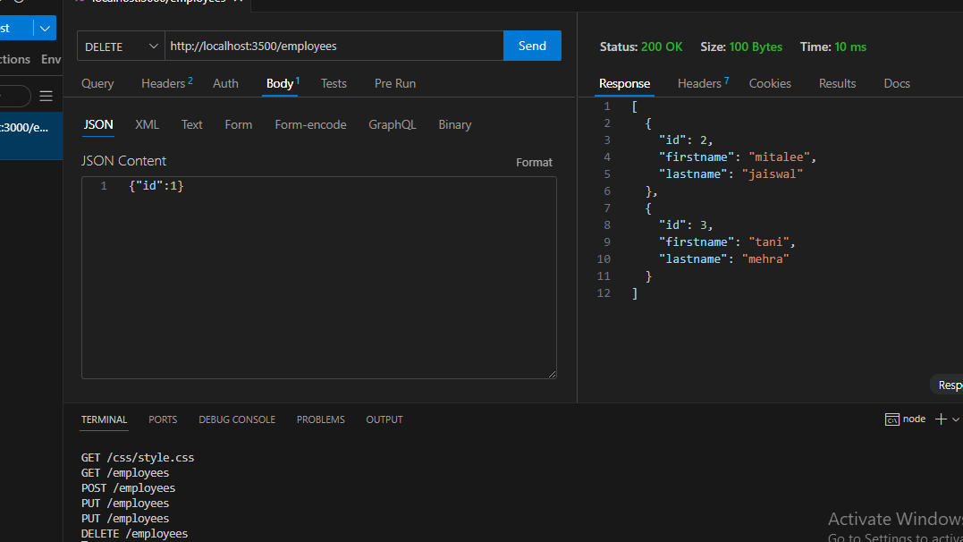

**10Authentication-**

For authentication we create seprate js file

1.auth.js,

2.register.js,and

also create users.josn in model folder

then

create folder controller

1.create authcontroller.js,employeecontroller.js,registercontroller.js

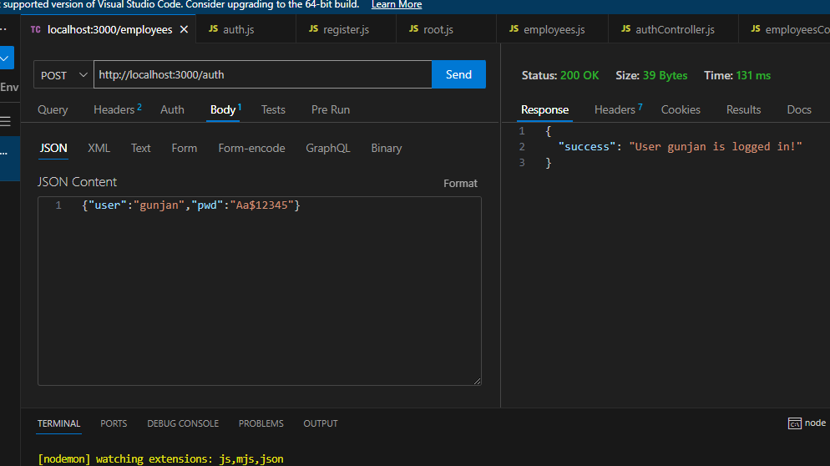

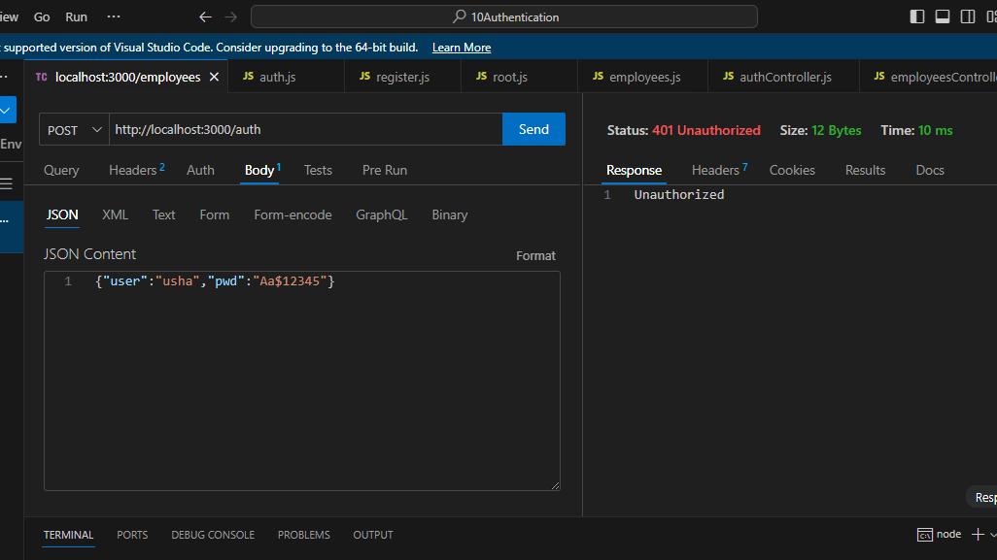

11.jwt-json web token

Access token=short time and

Refresh Token=Long time

1.Install-Npm I dotenv jsonwebtoken cookie-parser

How to generate token

1.create .env file write ACCESS_TOKEN_SECRETE=

2.REFERESH_TOKEN_SECRETE=

3.Open terminal-write –node enter

4.reuire(‘crypto’).randomBytes(64).toString(‘hex’) then copy token and paste to access_token_secrete then again same process to refresh token

**User rule & Autharization:**

Authentication VS Autherization-

1.Authentication🡪the process of verifying who someone is.

2.Autherization🡪the process of verifying what resources a user has access to.

JSON WEB TOKENS🡪

1.conform authentication

2.allow access to API endpoints

3.endpoints provide data resource

4.use authorization header

**What is MongoDB?**

MongoDB is an open-source, document-oriented NoSQL database management system.

**More About MongoBD**

It was created by a company called 10gen, which is now known as MongoDB ,in 2007.the first version of mongoDB was released in 2009.

**MongoDB Advantage:-**

Performance

Flexibility

Scalability

Usability

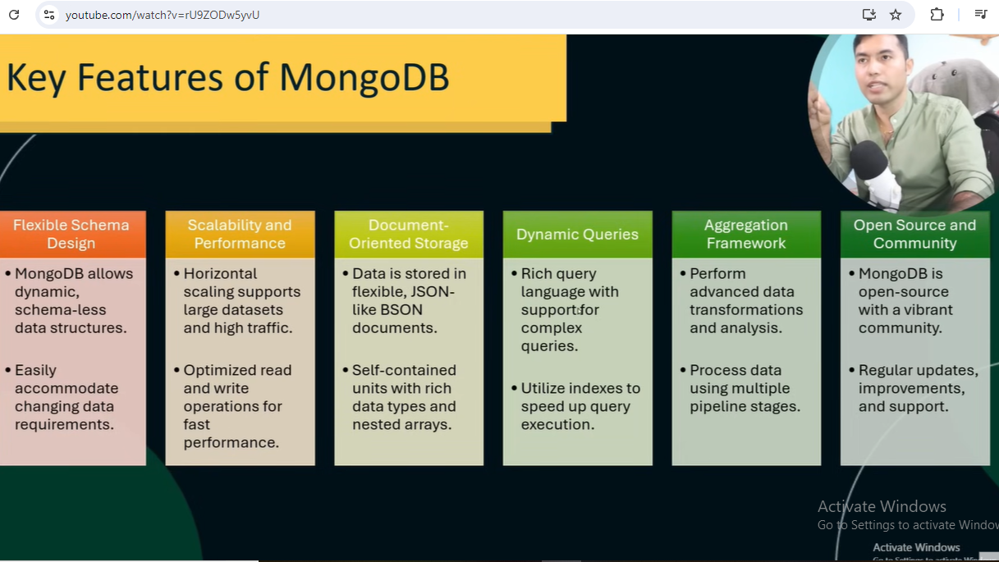

**Diff between**

(Realtional DB-in the form of tables)

(non Relational -In the form of documents)

|  |  |
| --- | --- |
| SQL | MongoDB |
| Sql databses are relational databases. | NoSQL databases are non-relational databases. |
| They use structures tables to store data in rows and columns. | They provide flexibility in data storage, allowing varied data types and structures. |
| Suitable for applications with well-defined schemes and fixed data structures. | Ideal for applications with dynamic or evolving data models. |
| E-commerce platform,HR Management etc | Social media platform, gaming |
| Ex-MySQL, PostgreSQL, Oracle. | Ex- MongoDB, Cassandra |
|  |  |

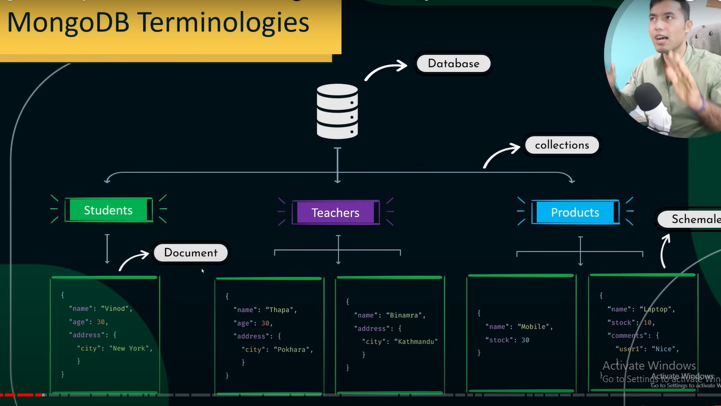

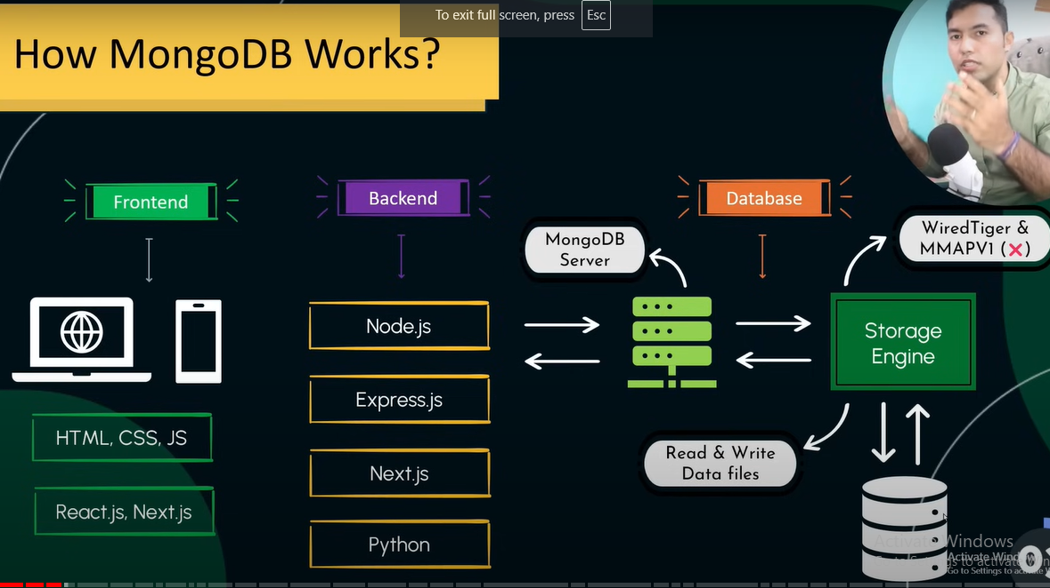

**Important-**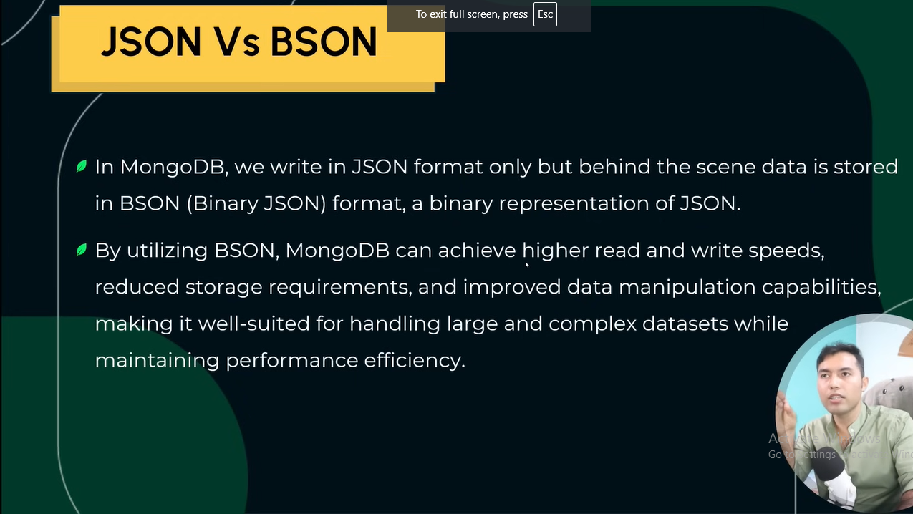

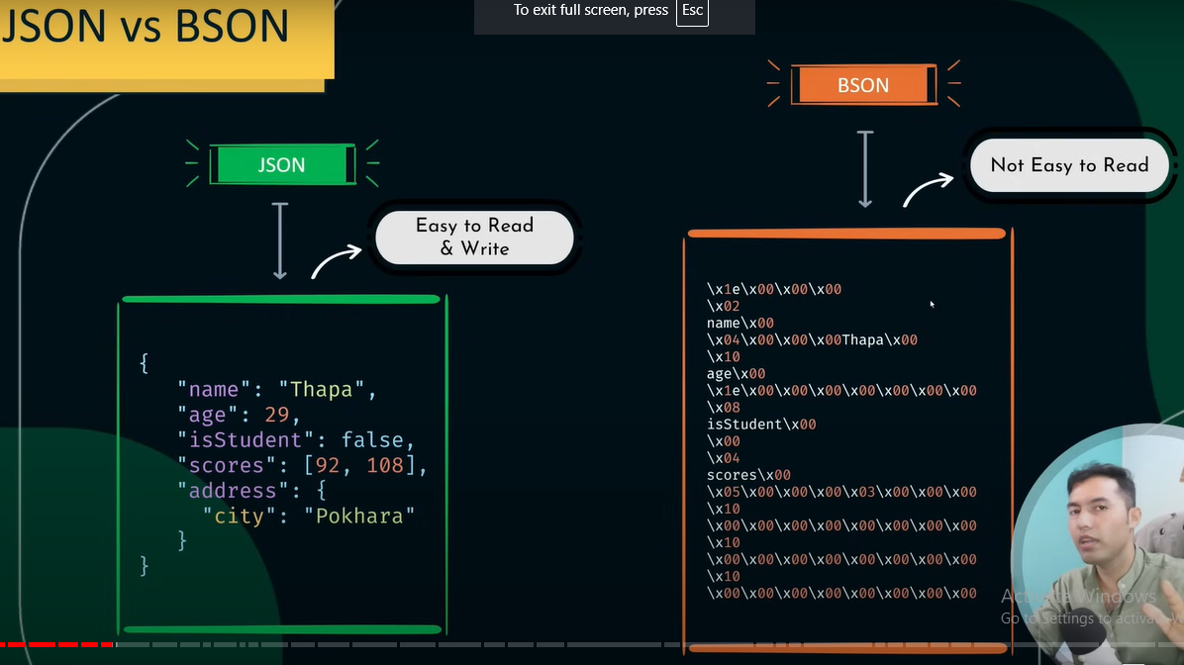

**Installing MongoDb-**

**First install this three:-**

<https://www.mongodb.com/try/download/community>

[https://www.mongodb.com/try/download/shell](https://www.mongodb.com/download/shell)

<https://www.mongodb.com/try/download/database-tools>

Then check version using-

mongod --version

mongosh this cmd also run

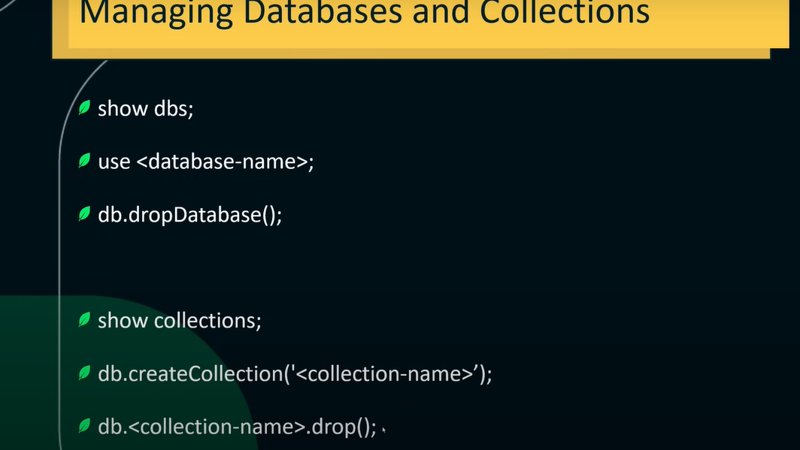

How to delete-

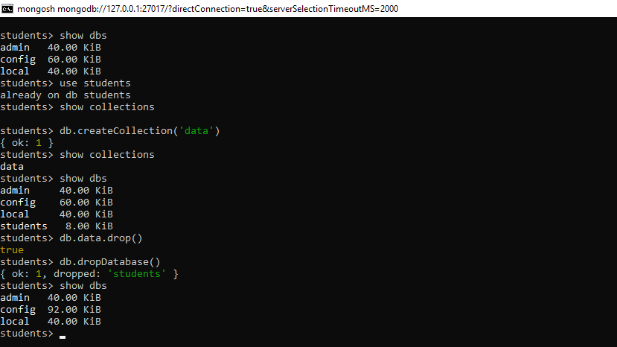

Insert Operation in mongoDb

1.Inserting Documents in MongoDb

2.When to use Quotes and when not to?

🡪Special Characters-

If a field name contains special characters or spaces, or starts with a numeric digit, using quotes is necessary.

🡪Reserved words-

If a field name is a reversed keyword in mongoDB, use quotes distinguish it from the reversed keyword.

3.Ordered and unordered inserts

4.Case Sensitivity in MongoDB

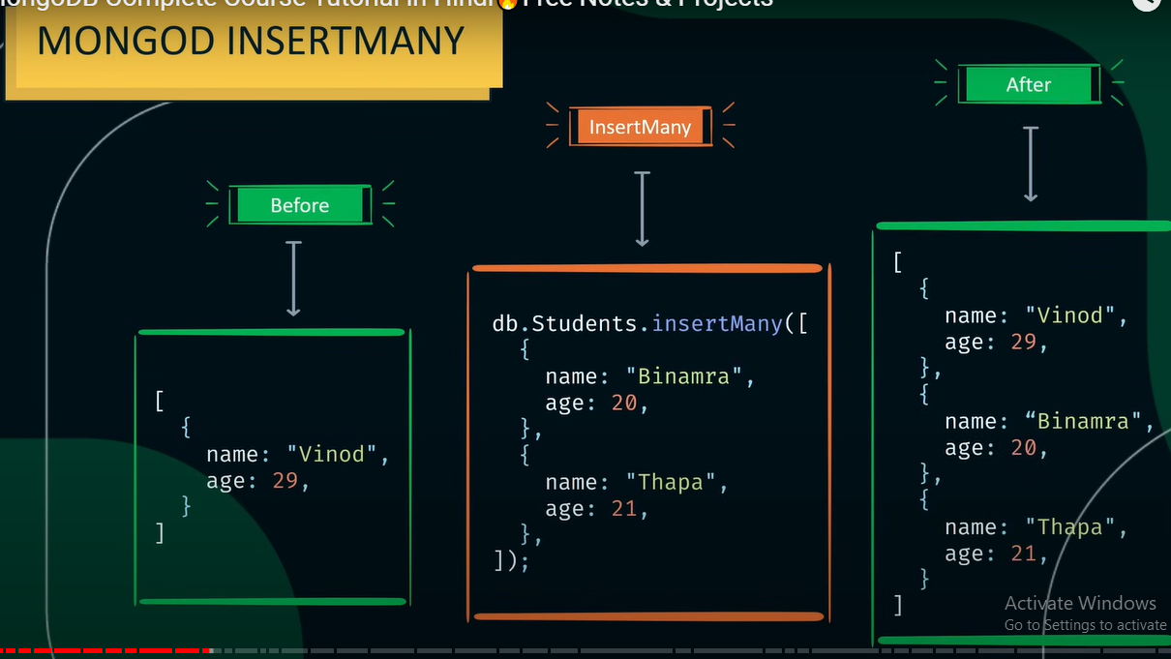

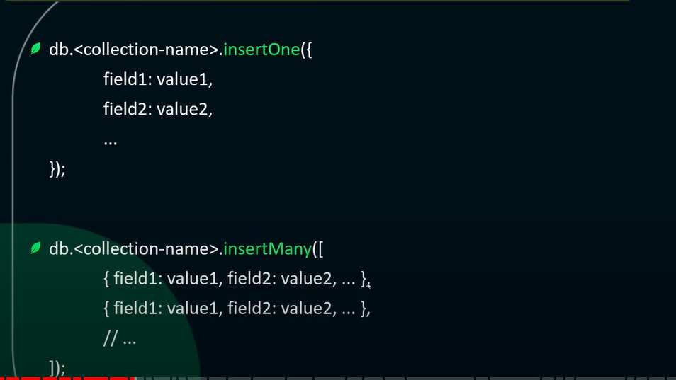

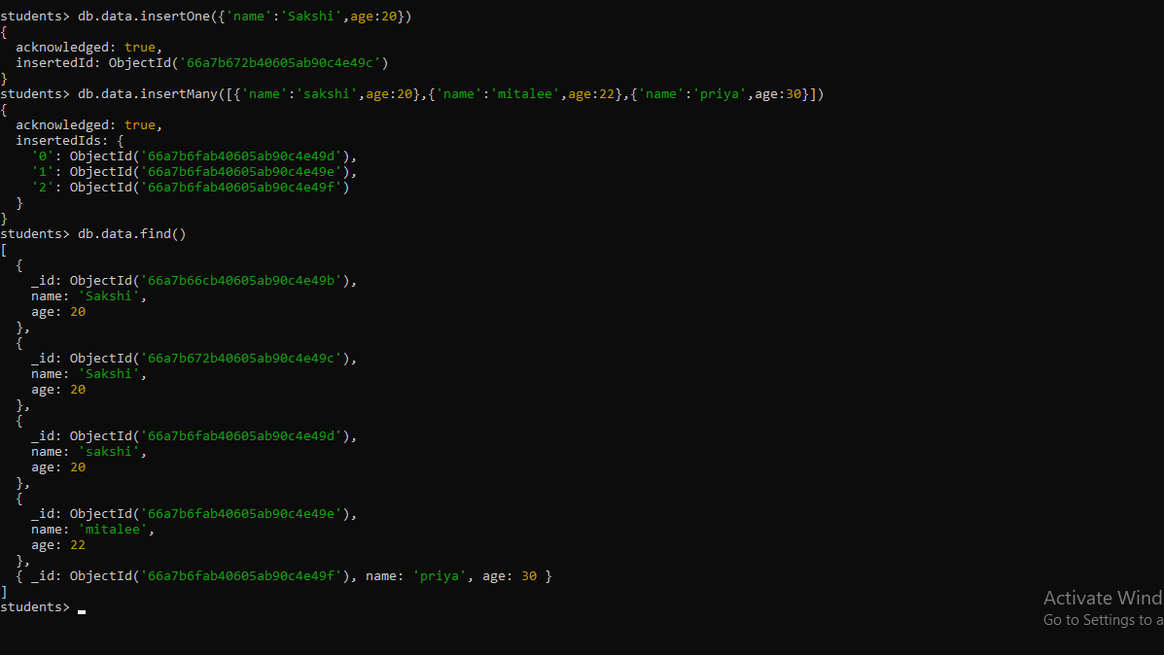

In the below ex we use db.data.find() 🡪 use for to see the data into the scehma

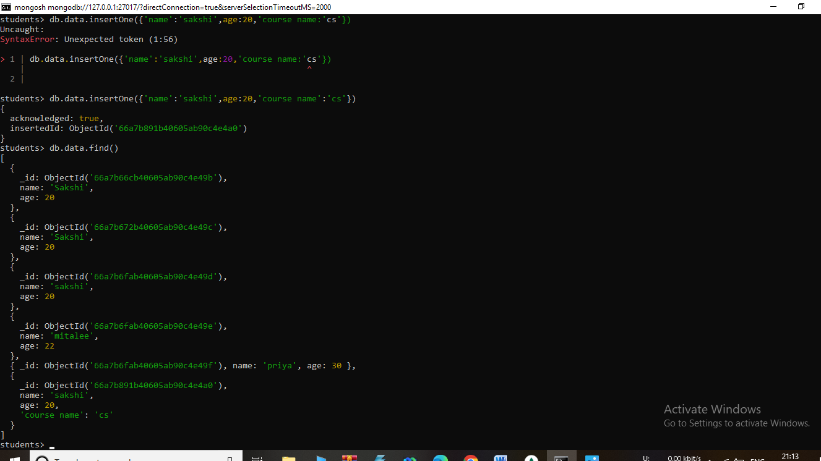

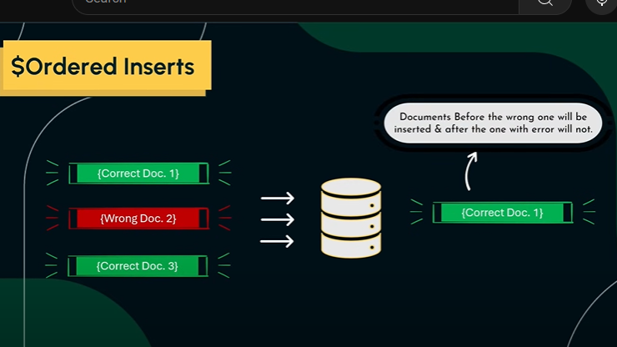

**Read Operations in MongoDB-**

Reading documents in MongoDB

Comparison Operators

Logical Operators

Cursors in MongoDB

Elements Operators

**How to find Particular data-**

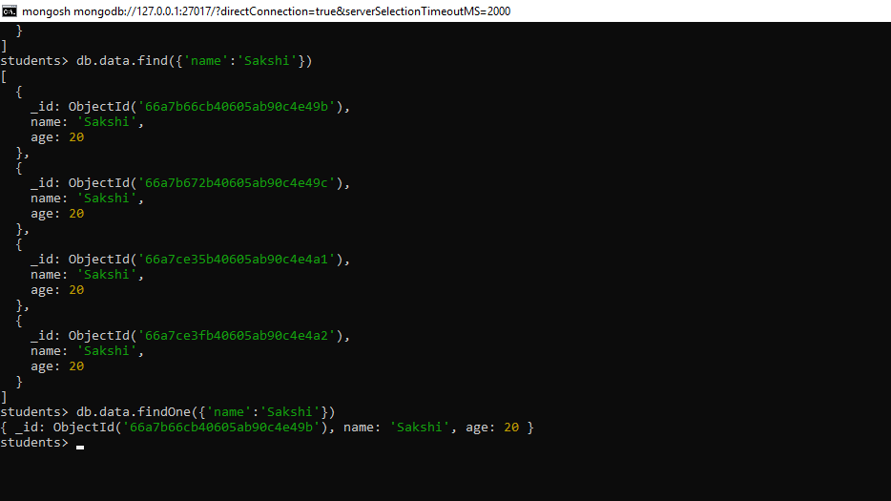

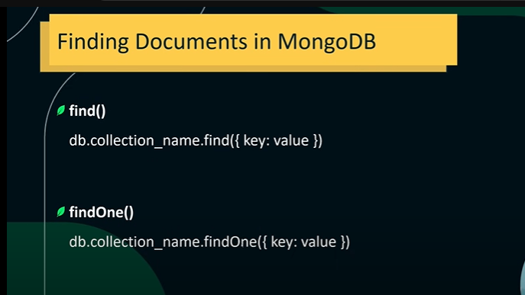

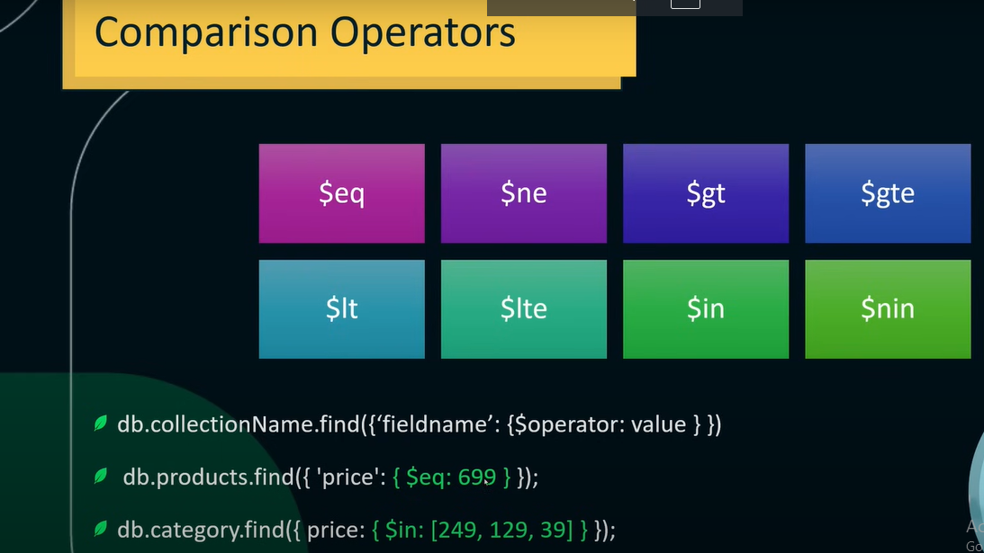

Logical Operator-

$and

$or

$not

$nor

**Complex Expressions-**

The $expr operator allows using aggregation expressions within a query.

Useful when you need to compare field from the same documents in a more complex manner.

Syntx-

{$expr:{operator:[field,value]}}

Example-

Db.products.find({$expr:{ $gt:[‘$price’,1340} });

**Elemnts Operator-**

$exists

$type

$size

{field:{$exists:<Boolean>}}

{ field:{$type:”<bson-data-type>”}}

{field:{$size :<array-length>}}

**Embedded Documents-**

Query Documents inside embedded documents using dot notation.

Db.collection.find({“parents.child”:value})

Ex-

Db.comments.find({‘comments.user’:’lily’})

Using condition-

1.Db.comments.find({‘metadata.views’:{$gt:1200}})

2.db.comments.find({‘comments.user’:’Henry’,’metadata.links:’{$gt:50}})

**$all vs $elemMatch**

Ex-

db.comments.find({‘comments.user’:{$all:[‘Alice’,’vinod’}})

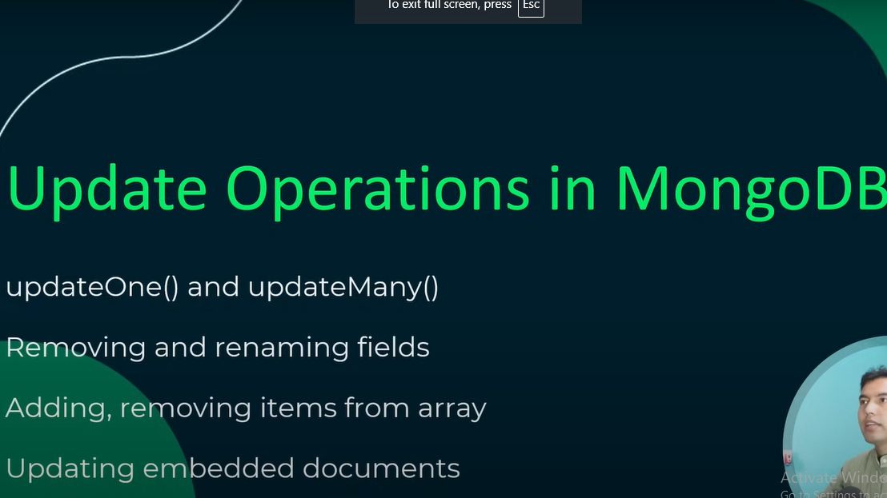

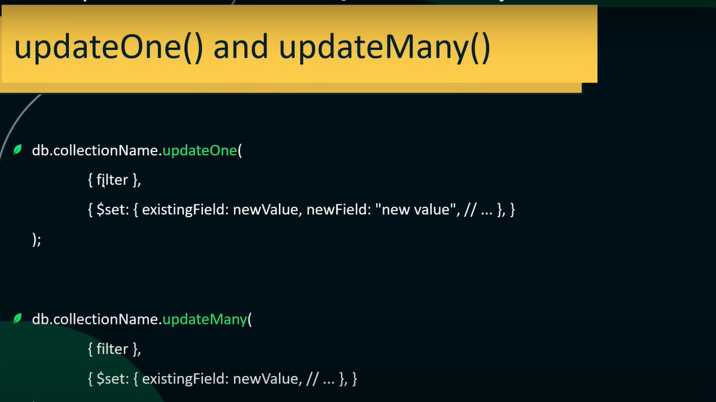

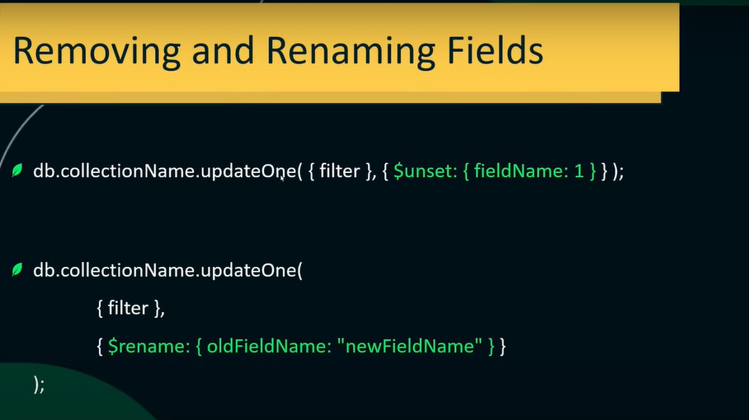

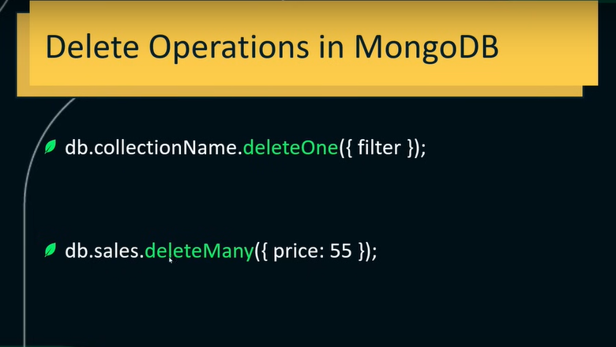

Delete recored-

db.comments.deleteOne({_id:1})

Indexes in MongoDB-

What is indexes?

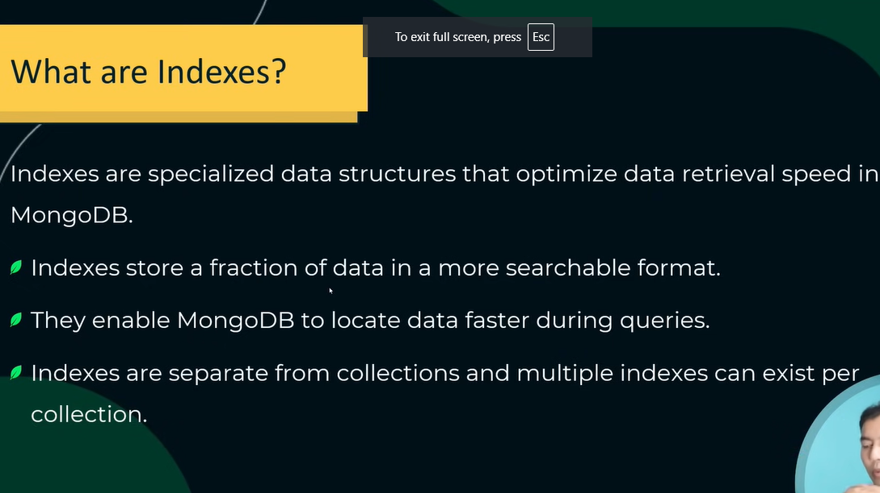

Benefits of indexes

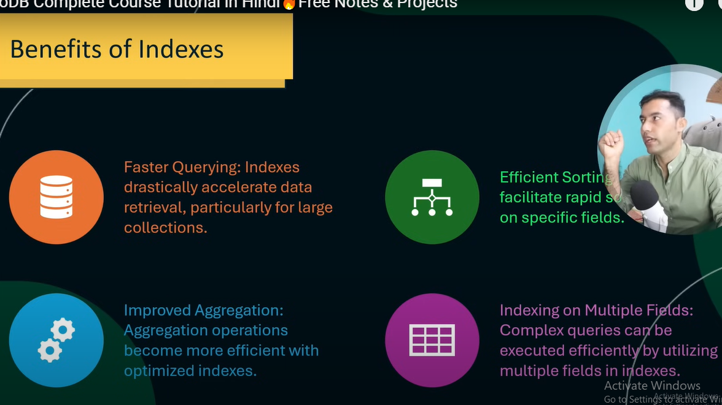

Managing indexes

Unique ,text index

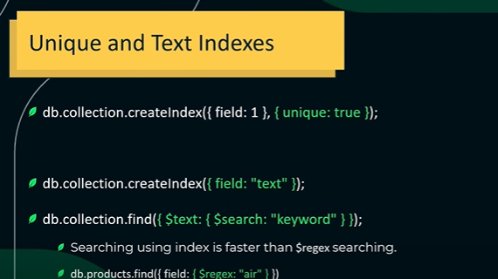

When not to use indexes?

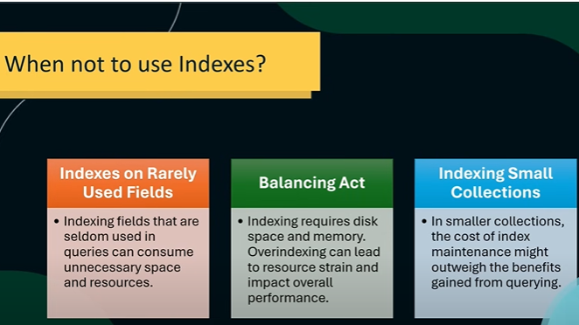

Aggregation-

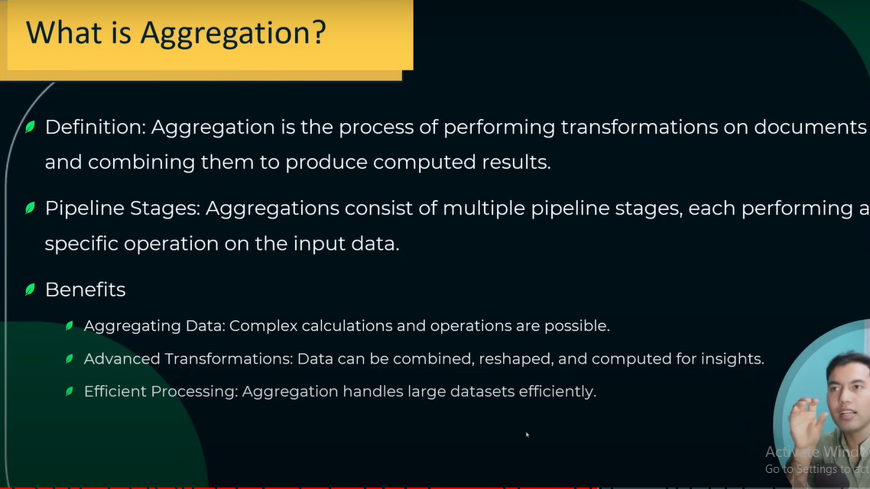

1.Match

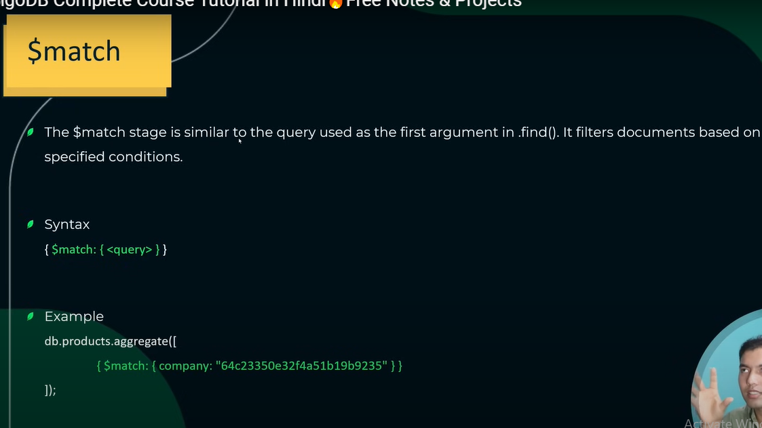

$match -Best part is that ki change nhi kr sakte outpt me

2.$group(continue)

3.$sort

4.$project

5.$push

6.$addToSet

7.$size- $group ke andar $size use nhi kr sakte

🡪//we can’t do this,bcz the $size operator is not allowed directly within the $group stage.Instead,you can use it in combinations with other aggregration operators or in separate pipeline stages.

8.$limit and $skip

9.$filter

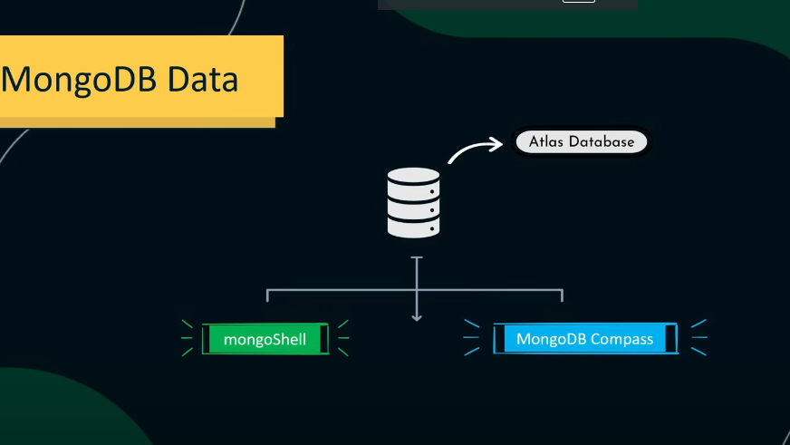

**Atlas-**

1.sign in Atlas create acc

2.Create databse

3.set db access

4.network access

5.go to overview

6.connect

7.shell

8.i have the mongoDB shell install

9.copy link paste to cmd and enter password.

